

A Project

Report On

**Interior Designer**

By

**Ankita Anant Sutar**

**B.E Computer Engineering**

**Batch: - 2020-5735**

**Center: -Thane**

Under the Guidance of,

**Shalini Kumari.**

**Technical Trainer**

**EduBridge**

(School of Coding)

**Introduction:**

This Project  **Interior Designer** has been developed by using HTML language and design by using CSS. This is a website for the Interior Designers .The purpose of this website is to Explore designer ideas to the peoples who wants to decorate their house as they wish.

In this website, users can see what Services we offers. In this website, users can contact with us as we provide the official E-mail-id and Mobile number etc. or if user’s have any query then they can message us by providing there name and email-id . In this website user can see

Our previous projects and work.

Software Requirements:

Front end: HTML and CSS

IDE: VS Code

Operating System: Window 10

Output:

**1.Welcome Page:**

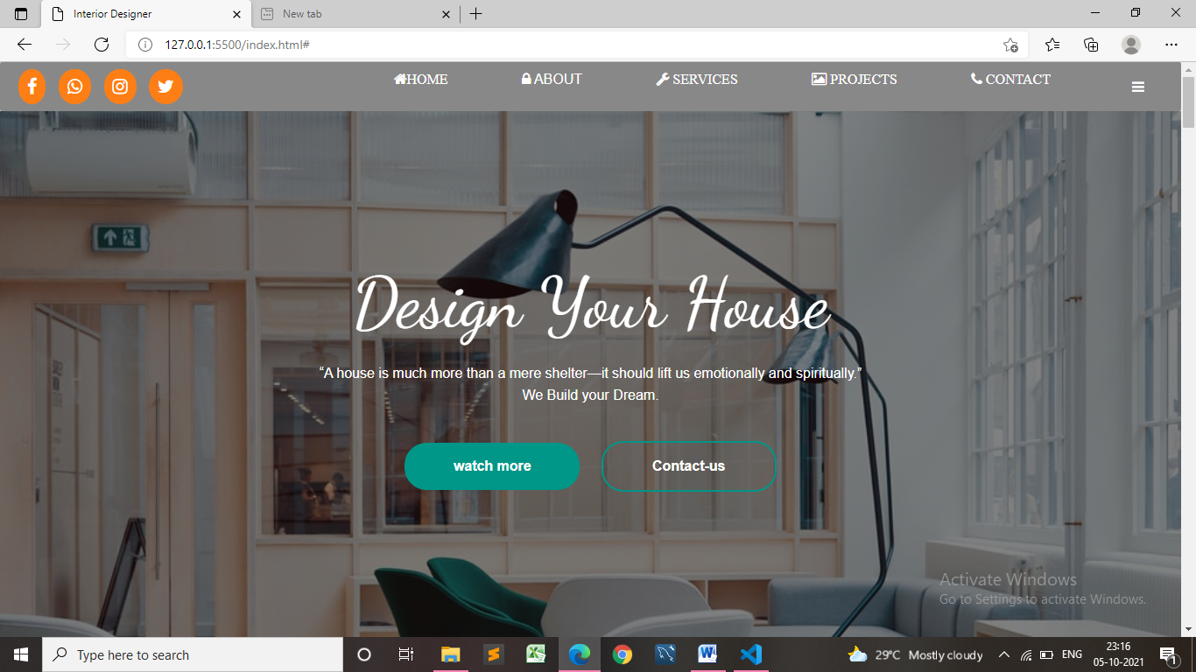

Fig: 1

**2.ABOUT US:**

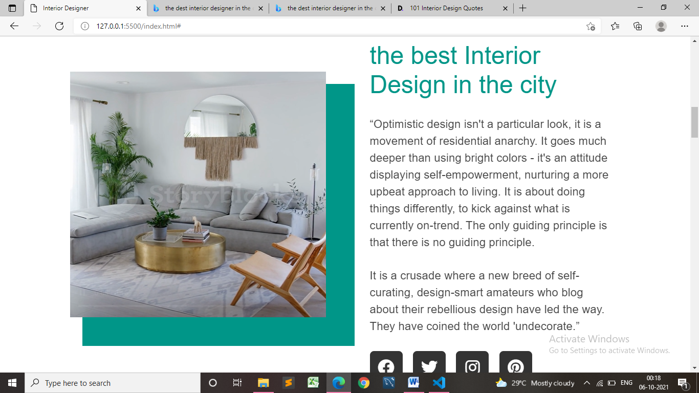

Fig : 2

**3.Our Services**:

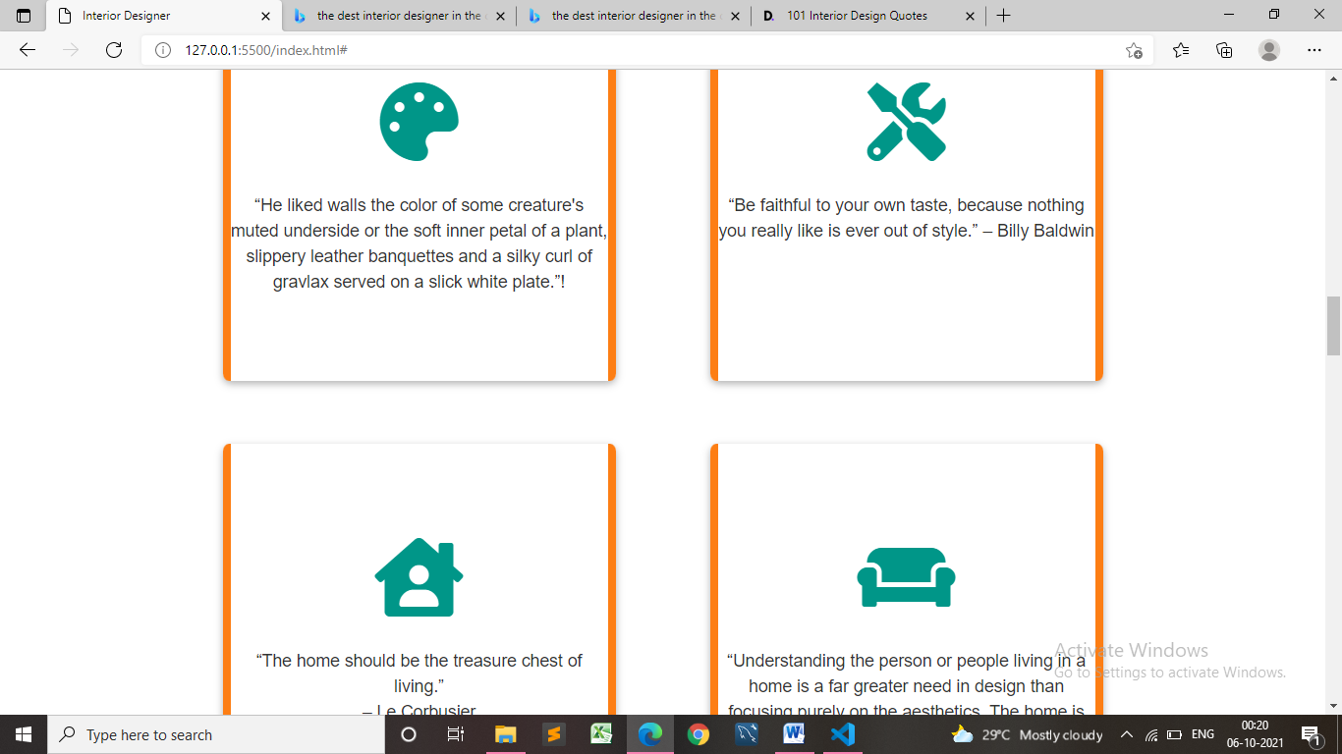

Fig: 3

**4. Our Projects :**

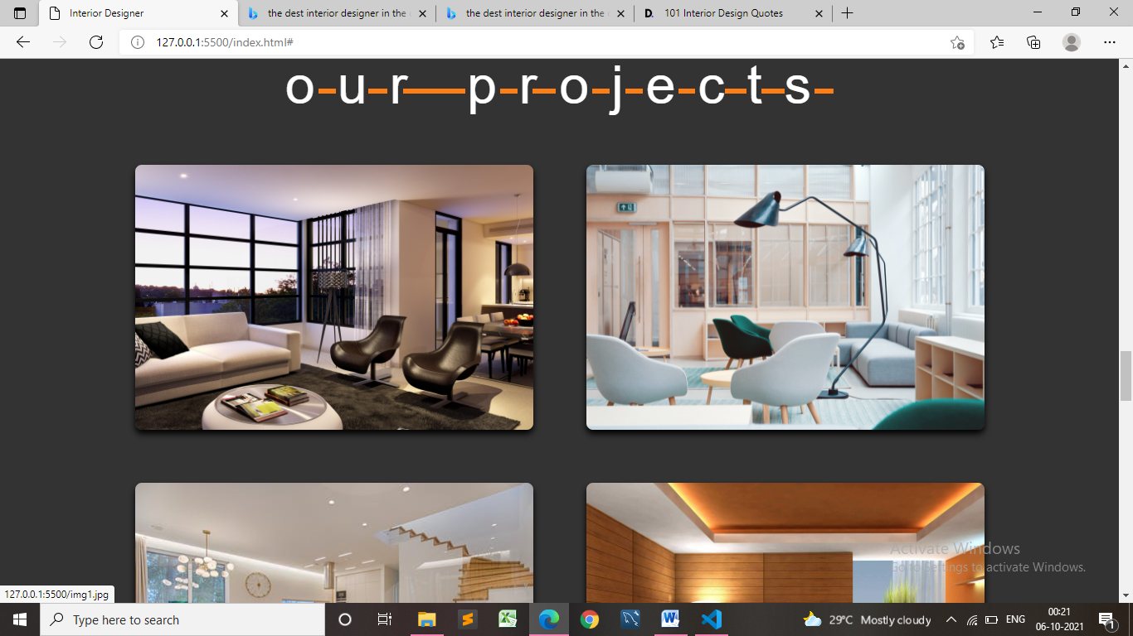

Fig: 4

**5.Clients-WorkingHours-project:**

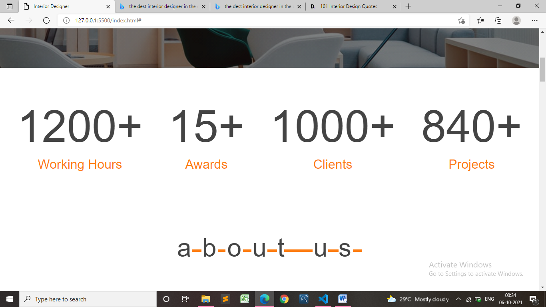

Fig: 5

**6.Contact-Us:**

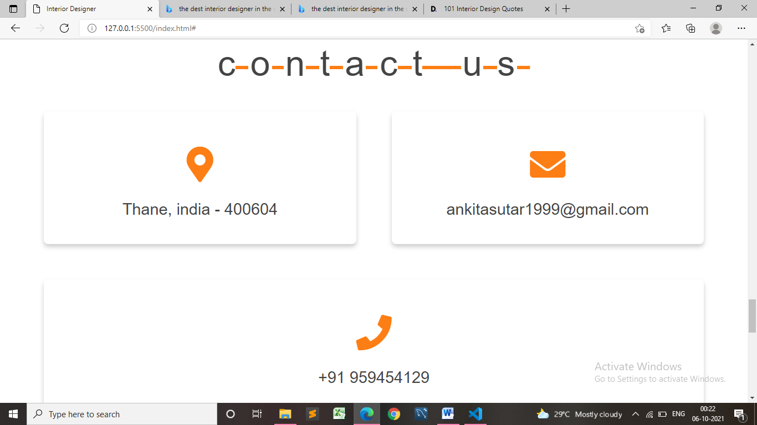

Fig: 6

**7. Contact-Us:**

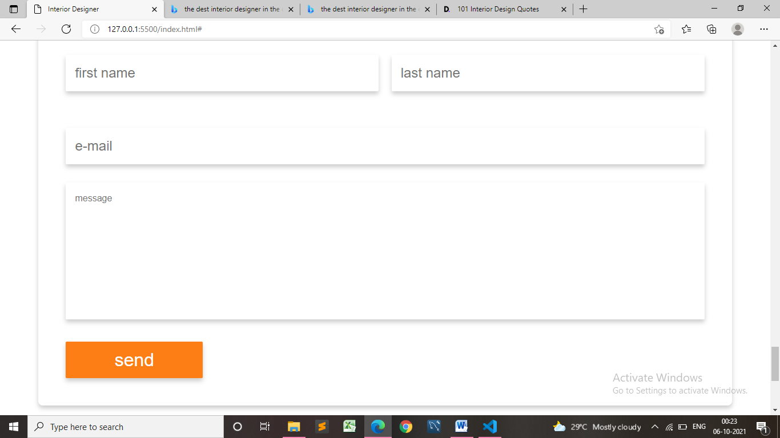

Fig: 7

**8. Footer:**

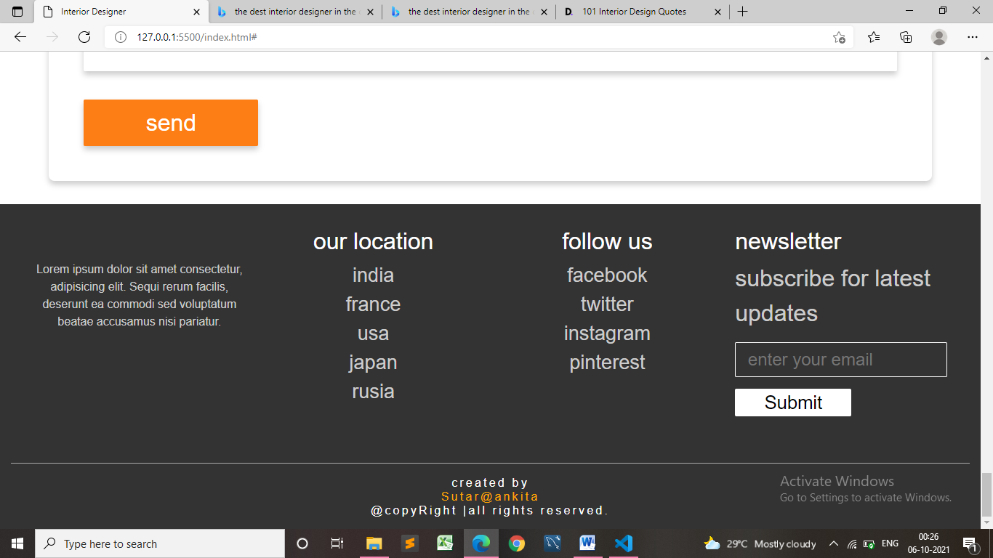

Fig: 8

***Interior Designer Website***

***Has been completed***